A LA CARTE

**EXOTIC CHILLED FRUIT SOUP**sorbet / ragout / cremant  
13

**SWABIAN ROAST BEEF**fried onions / port wine jus / vegetables / cheese spätzle  
31

**FREGOLA-RISOTTO**mangel / chanterelles / smoked tofu  
27

**GRILLED SQUID**homemade sepia-noodles / tomato / basil-oil  
34

**GRILLED ANGLERF FISH**mint / grilled watermelone / edamame / artichoke  
33

Dear guests,

we warmly welcome you

in the “klebers” restaurant and are happy

about your visit with us.

According to our motto

"Imaginative - tasteful - joyful"

we have devised and prepared three menus for you.

In addition, we offer you various delicacies à la carte. Of course, you can also choose dishes individually

select from the menus.

Should we not leave you without a wish with our selection

happy, please contact us

to our team in the restaurant.

Now we wish you an enjoyable and joyful one

Experience with us in the "klebers"!

For the whole kitchen team, yours

Walter Varga and Christian Brändle

Please talk to our service staff about allergens and intolerances.

We will be happy to provide you with the explanatory list if necessary.

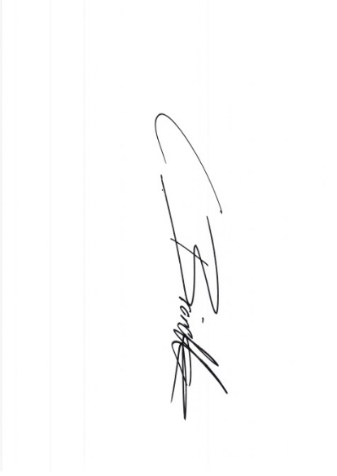

MENU VEGETARIAN  
53

**CREAM SOUP OF CHANTERELLES**herb-chanterelles / strudel

~~~~~

**HOMEMADE CARAMELLE NOODLES**betroot-noodles / white tomato-sauce  
buffalo-mozzarella / courgette-pearls

~~~~~

**CHEESECAKE-SLICE**shortbread / berries / sorbet

MENU REGIONAL  
69

**SMOKED SALMON TROUT**mustard- caviare / cucumber-gazpacho / cashew-creme / yogurt

~~~~~

**FILET OF SUCKLING PIG**mille-feuille / shallots / mashed potatoes with leeks

~~~~~

**BLACK FORREST CHERRY CAKE**cherryragout / bisquit / mascarpone-icecream / chocolate

MENU KLEBERS  
90

**CLEAR FISHSOUP**enriched with tomato paste / saffron / scallop / king prawn

~~~~~

**SWORDFISH-CARPACCIO**balsamic-caviar / sundried tomato  
avocado / enoki

~~~~~

**FILET OF BEEF**Madeira-sauce / chanterelles / roasted coliflower

~~~~~

**MANGO-CREME-BRÛLÉE**pistachio / coconut-sorbet